LAB TEST- 1
QUE-1:
TASK-1:
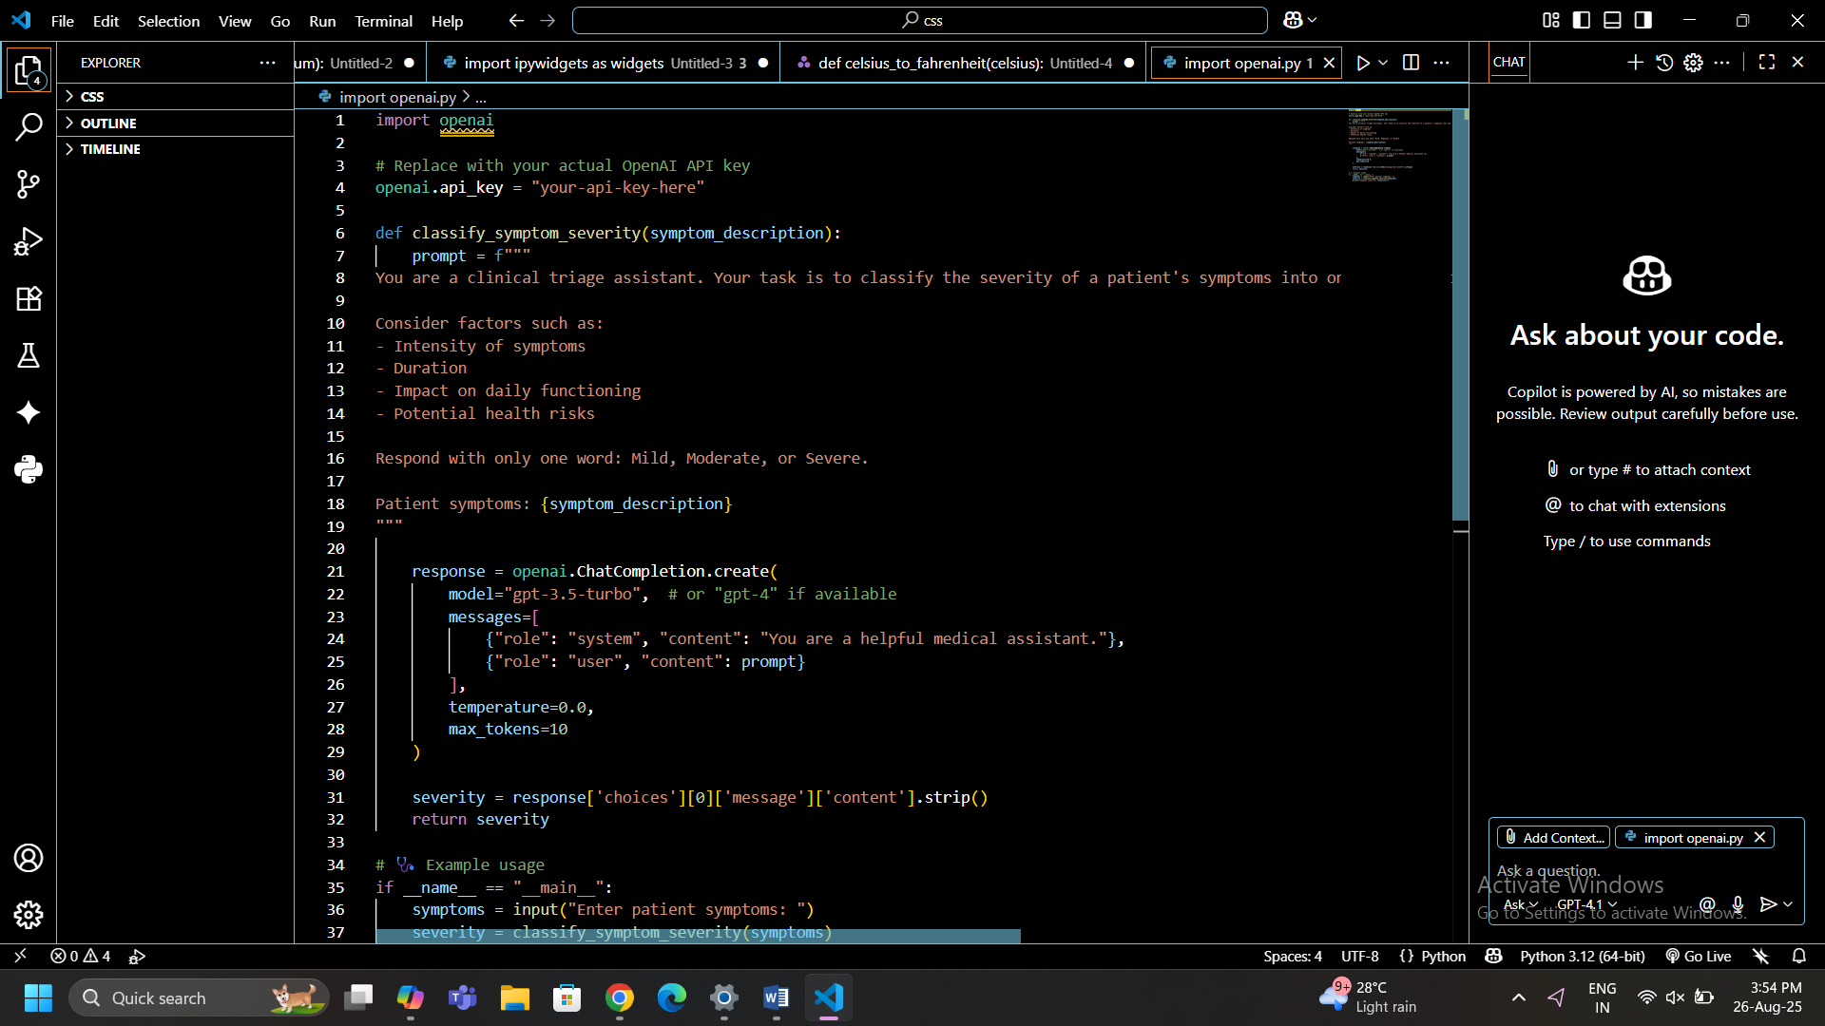
TASK-2:
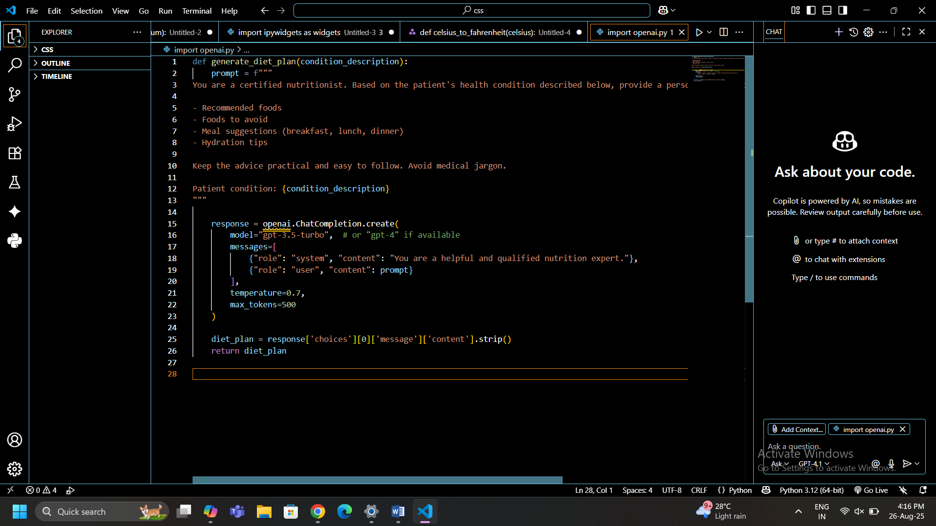
QUE-2:
TASK-1:
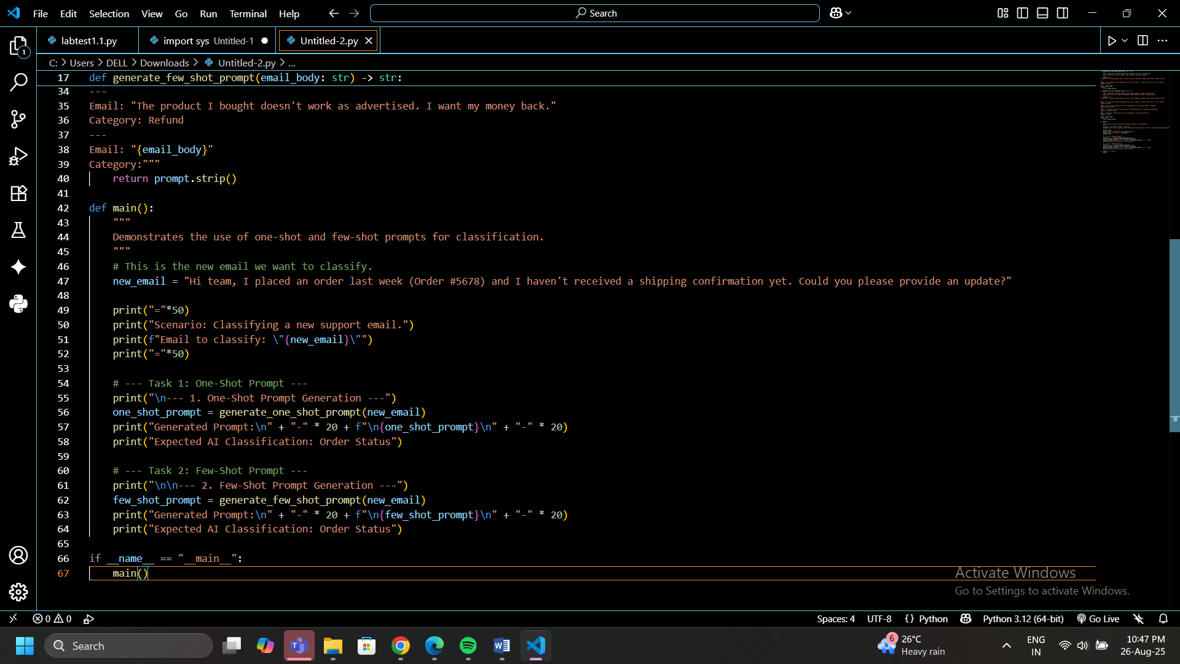
TASK-2:

OUTPUT:
THE DIFFERENCE IS
Classify the following support email into one of these categories: Refund, Order Status, Technical Issue.

---
Email: "Hi, I received my order #12345 but the item is broken. I'd like to return it for a full refund."
Category: Refund
---
Email: "Hi team, I placed an order last week (Order #5678) and I haven't received a shipping confirmation yet. Could you please provide an update?"
Category:
Classify the following support email into one of these categories: Refund, Order Status, Technical Issue.

---
Email: "Hi, I received my order #12345 but the item is broken. I'd like to return it for a full refund."
Category: Refund
---
Email: "Hello, can you please tell me where my package is? The tracking number is XYZ-987."
Category: Order Status
---
Email: "I'm trying to log into my account but I keep getting an error message. Can you help?"
Category: Technical Issue
---
Email: "The product I bought doesn't work as advertised. I want my money back."
Category: Refund
---
Email: "Hi team, I placed an order last week (Order #5678) and I haven't received a shipping confirmation yet. Could you please provide an update?"
Category:

